**DATE:** 28TH March, 2025

**FROM: THE GENERAL SECRETARY**

**TO: ALL NEC MEMBERS**

**SUBJECT: NOTICE OF MEETING OF THE NATIONAL EXECUTIVE COUNCIL OF NIGERIAN BAR ASSOCIATION.**

Distinguished NEC Members,

Notice is hereby given of the meeting of the National Executive Council of the Nigerian Bar Association on the date, time and venue specified hereunder.

**DATE:** Thursday 15th May, 2025

**TIME:** 9:00 am Prompt

**VENUE:** Banquet Hall, Ahmadu Bello Way, Ilorin, Kwara State

**AGENDA:**

1. NEC Prayer
2. Review of the Minutes of the last NEC Meeting of Thursday, 6th February, 2025
3. Matters Arising from the Minutes
4. President’s Speech
5. National Secretariat Report
6. Reports from Sections, Fora and Committees
7. State of the Nation
8. Any other Business

Attendance is limited only to the underlisted NEC Members:

1. National Officers

2. Past Presidents

3. Past General Secretaries

4. Branch Chairmen

5. Branch Secretaries

6. Chairmen and Secretaries of Sections, Fora and Committees

7. Co-Opted NEC Members

8. Pre-registered Observers

Note that the meeting shall be held hybrid. Therefore, link to attend virtually, and documents for the meeting (NEC Bundles and Secretariat Reports) would be circulated to the NEC Members ahead of the meeting.

For further enquiries, contact the **Office of General Secretary** or calltheBar Services Department on +234-803-345-2825. For booking and reservation of hotel accommodation, contact theWelfare Secretary on +234-816-262-5324.

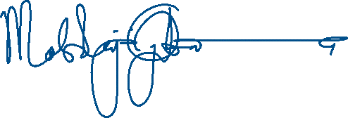

**DR. MOBOLAJI OJIBARA**

General Secretary